CPE301 – SPRING 2019

Design Assignment 2B

Student Name: Tyler Gardenhire

Student #: 8000450294

Student Email: gardenhi@unlv.nevada.edu

Primary Github address: [gardenhi@unlv.nevada.edu](mailto:gardenhi@unlv.nevada.edu)

Directory: https://github.com/tylergardenhire/submission_projects.git

Submit the following for all Labs:

1. In the document, for each task submit the modified or included code (only) with highlights and justifications of the modifications. Also, include the comments.
2. Use the previously create a Github repository with a random name (no CPE/301, Lastname, Firstname). Place all labs under the root folder ESD301/DA, sub-folder named LABXX, with one document and one video link file for each lab, place modified asm/c files named as LabXX-TYY.asm/c.
3. If multiple asm/c files or other libraries are used, create a folder LabXX-TYY and place these files inside the folder.
4. The folder should have a) Word document (see template), b) source code file(s) and other include files, c) text file with youtube video links (see template).

1. **COMPONENTS LIST AND CONNECTION BLOCK DIAGRAM w/ PINS**

Atmel Studio 7 w/ AVR assembly and simulator and Atmega328p board used.

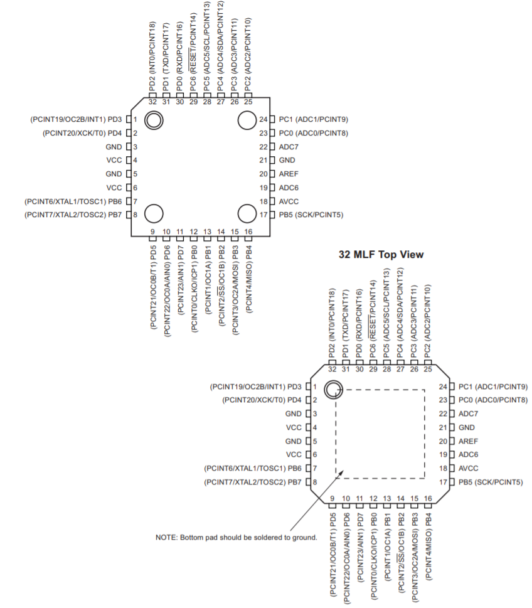

PortB2 is connected to LED3 and PortC2 is connected to SW1.

1. **INITIAL/MODIFIED/DEVELOPED CODE OF TASK 1/A**

Task 1 Assembly Code:

.org 0 ;location for reset

jmp start

.org 0x02 ;location for ext_int0

jmp ex0_isr

start:

ldi r20, high(RAMEND)

out sph, r20

ldi r20, low(RAMEND)

out spl, r20 ;initialize stack

ldi r16, 0x00 ;initialize output

ldi r20, 0x2

sts eicra, r20 ;make INT0 falling edge triggered

sbi ddrb, 2 ;set portb2 as output (led)

sbi portd, 2 ;set pull up

ldi r20, 1<<int0 ;enable INT0

out eimsk, r20

sei ;enable interrupt

off:

out portb, r16

rjmp off ;turn led off until interrupt

delayon: ;delay for 1.25 seconds

ldi r20, 100

delayon1:

ldi r21, 100

delayon2:

ldi r22, 200

delayon3:

nop

nop

dec r22

brne delayon3

dec r21

brne delayon2

dec r20

brne delayon1

ret

ex0_isr:

in r21, portb

ldi r22, (1<<2) ;toggles pb5

eor r21, r22 ;toggles led pb2

out portb, r21 ;turn led pb2 on

rcall delayon ;call delay

reti ;return here until interrupt

Task 1 C Code:

#define *F_CPU* 8000000UL //set cpu mhz for delay

#include <avr/io.h>

#include <avr/interrupt.h>

#include <util/delay.h>

int main(void)

{

DDRB |= (1<<2); //set pb2 as output

PORTB &= (1<<2); //clear pb2

PORTD = 1<<2; //enable pd2

EICRA = 0x02;

EIMSK = 1<<INT0; //enable pc set 0 interrupt

sei(); //enable global interrupt

while (1);

}

ISR(INT0_vect)

{

PORTB ^= (1<<2); //toggle pb2 during interrupt

*_delay_ms*(1250); //delay for 1.25 seconds

PORTB ^= (1<<2); //toggle pb2 during interrupt

}

1. **DEVELOPED MODIFIED CODE OF TASK 2/A from TASK 1/A**

N/A

1. **SCHEMATICS**

N/A

1. **SCREENSHOTS OF EACH TASK OUTPUT (ATMEL STUDIO OUTPUT)**

Task 1:

Assembly:

Full period is 1.25 s, the following screenshot was taken at the end of one loop.

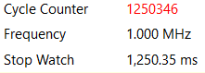

C:

Full period is 1.25 s, the following screenshot was taken at the end of one loop.



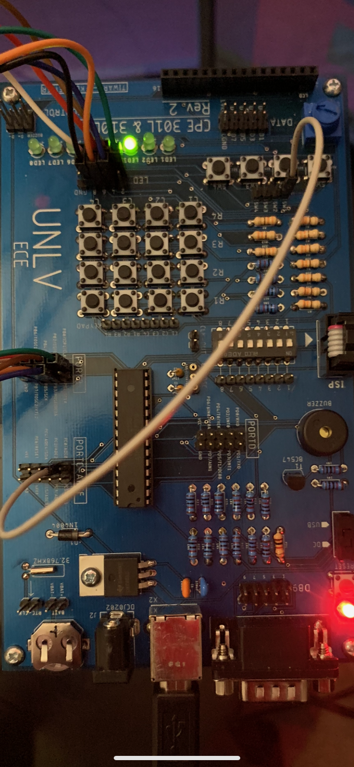

1. **SCREENSHOT OF EACH DEMO (BOARD SETUP)**
2. **VIDEO LINKS OF EACH DEMO**

<https://youtu.be/uixC4MPNSFE>

1. **GITHUB LINK OF THIS DA**

https://github.com/tylergardenhire/submission_projects.git

**Student Academic Misconduct Policy**

<http://studentconduct.unlv.edu/misconduct/policy.html>

“This assignment submission is my own, original work”.

TYLER GARDENHIRE